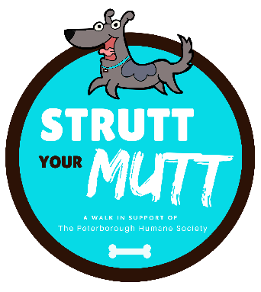
EVENT RULES

We want everyone at Strutt Your Mutt to have a Fur-tastic time! In light of this, please carefully read the rules for dogs and people. Additionally, thoroughly read and sign the waiver to participate in the event. One waiver needs to be completed for each participant.
- Participating dogs much be currently licensed with proof of Parvovirus and Rabies vaccinations. You do not need to bring proof with you; if an incident occurs you must be able to produce proof in a reasonable amount of time.
- For safety reasons, retractable leashes (aka “extend-a-leash” or “flexi-lead”) will NOT be allowed. Dogs must be kept on a leash at all-time no more than six-feet in length.
- Female dogs in heat are not permitted
- Strutt Your Mutt reserves the right to refuse entry to any dog whose observed behavior could be dangerous to others. Please use good judgment regarding temperament of your pet so that this event will be safe and enjoyable for everyone.
- With concern for safety, no bikes, skateboards, roller blades etc. are allowed. Baby strollers are permitted
- Be sure you and your dog are practiced and prepared for the walk
- Please only bring your dog if they enjoy being around people and other dogs
- Be sure your dog is wearing their current ID and license tags
- PLEASE … clean up after your dog! Poop bags will be provided at the event.

