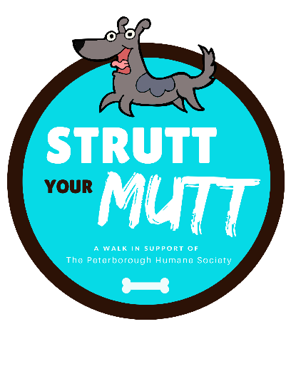
Making the MOST of your BOOTH
Increase your visibility by using our hashtag #StruttYourMuttPTBO

We want you to get the MOST out of your experience at Strutt Your Mutt! We are expecting a TON of people stopping by to check out this event … pet owners, home owners, business people, families and children, so instead of getting lost in the shuffle, here are our tips to getting people to stop at your booth:

- HAVE SOME CURB APPEAL
Have clear signage displaying the name of your business. It doesn’t have to be a banner or very large, but a simple “8.5 x 11” sign will do! Display your items so that people can easily see what you have. Instead of laying everything flat, consider vertical displays. As well keep your table looking full, empty space may lead people to believe that all of the good things have gone already.
- LET THEM BARK YOUR WAY
Have your business cards available or flyers with all current contact information. Are you a social media savvy business?! Display your handles widely and tell people to ‘like’ or follow for further information and updates. For visibility at the event use our hashtag #StruttYourMuttPTBO
- MAKE SOME FUR-EVER FRIENDS
Ask them their name and use it! Most people don’t use names in conversation, which is a strong way to bond and be remembered. Making genuine connections is essential!
- PURR-FORM WITH GIVEAWAYS AND GIMMICKS
It’s hard to get noticed and pulling out something extra special can draw a crowd. Giveaways and promotional items are great to entice people to come over. As well, Prize wheels, raffles, music, having candy or other food items and other gimmicks really do take it to the next level! Put on a show and you’ll have an audience!
- DON’T BE A CAT-TER BOX
A dog walk is a great place to meet potential clients and customers, but don’t waste all of that valuable time doing all the talking. Listening and connecting with potential clients goes a long way. Listen to what they need and you will be closer to establishing a new relationship and connecting with the right people.

Peterborough Humane Society 385 Lansdowne Street East Peterborough, ON K9L 2A3 (705) 745-4722 | s.dunkely@ptbohs.com | #RR001119251056

